Marwood Primary School Art & Design Provision

EYFS | Autumn 1 | Autumn 2 | Spring 1 | Spring 2 | Summer 1 | Summer 2
 | Myself, My Family and People around me | How do I feel today? | Keeping Safe and Healthy | A Cold Place | Plants and Animals | Kings and Queens
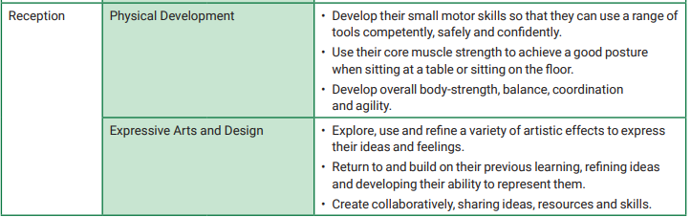
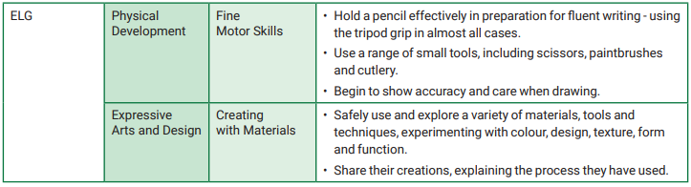

 | Autumn A | Spring A | Summer A | Autumn B | Spring B | Summer B
KS1 | Dinosaurs  Collage  Dinosaurs  Sculpture / Artist? (Augusta Savage?)  3D clay animal tiles based on dinosaurs. Create appropriate background as well. | Food around the World  Textiles  Plaiting and weaving: woven table mat with plaited edge. | Homes  Painting / Artist  Work based on Henri Rousseau (need to change as UKS2 artist). | Transport  Drawing / Artist – Portraits of key historical figures. Andy Warhol | The seaside  Textiles  Tie-dye/applique – seascape textile art.  Investigate best fabrics for tie-dye. | Collections  Sculpture  Clay plates – Portmeirion (Susan Williams-Ellis)  Printing  Own plate designs
LKS2 | Painting: Oceans /water (colours, brush techniques, effects)  Work of other artists: William  Turner. Claude Monet  Printing: The Great Wave off Kanagawa by Hokusai (use more than one colour to layer) | Sculpture: Use clay to create Ancient Greek pottery Painting: Research Greek art and paint pot | Drawing: Observation drawings of nature (pencil skills)  Work of other artists: Salvador Dali | Drawing: Cave painting (Charcoal drawing)  Collage: Lauren Child illustrations  (Montage) | Textiles: Weaving | Exploring and developing ideas:  Create animation using i-pads.  i Animate (Creating ideas)
UKS2 | BLOCK PRINTING  TEXTILES: Weaving  Viking patterns, design and symbols | MEET THE ARTISTS - Painters/ Architects /Designers Franz Marc –German /Gaudi –Spanish /Seurat – French (pointilism)  Warhol – American | DRAWING: PERSPECTIVE vanishing points, shade and tone)  Artist Peter Thorpe: Space | SCULPTURE  Human form modelling | BOTANICAL ART  Pencil sketching & water colour techniques.  NATURAL COLLAGE (National Geographic) Use fresh flowers and leaves to create an insect image. Texture, shapes, block colour  PRINTING:  Mono / block/ relief | COLLAGE & TEXTILES –Rainforest - Rousseau  POP ART  Romero Britto  PORTRAITURE  Frida Kahlo

