Author visit and book signing
We were fortunate to welcome author, poet and story teller, Chitra Soundar, into school on Tuesday October 5th.
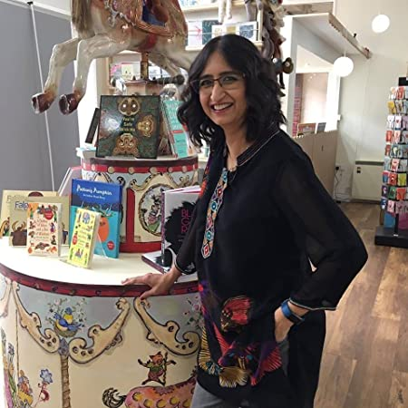
Chitra Soundar is an Indian-born British writer, storyteller and author of children's books, based in London. Chitra grew up on a wholesome diet of stories from Indian myths, epics and folklore. She's funny with friends, plays pranks at work and puts a lot of jokes into her books that are usually set in India or in Indian homes. She is keen to create stories with Asian themes and protagonists that have broad appeal to children from all backgrounds.
Chitra has been a teacher, programmer and other complicated jobs that grownups do in an office. She has written picture books, stories for emerging readers, poetry and junior fiction. She occasionally writes some poems too. Chitra's picture books, especially The Farmer Falgu series have been translated into French, German, Thai, Japanese and American English and are quite popular amongst children. In the UK, Chitra is published by Walker Books, Otter-Barry Books, Lantana Publishing, Bloomsbury amongst others. She has over 30 books in print worldwide. In 2018, A Jar of Pickles and a Pinch of Justice won the Eugenie Summerfield Children's Book Prize.
You can find out more about her here:
https://www.chitrasoundar.com/
In her workshop with each class, she captivated us with stories of growing up, her writing process and her books:
Pattan’s Pumpkin
A Dollop of Ghee and a Pot of Wisdom
A Jar of Pickles and a pinch of Justice
A Sliver of Moon and a Shard of Truth
Sona Sharma : Very Best Big Sister

