Marwood School Computing Provision

Reception | Autumn A | Spring A | Summer A | Autumn B | Spring B | Summer B
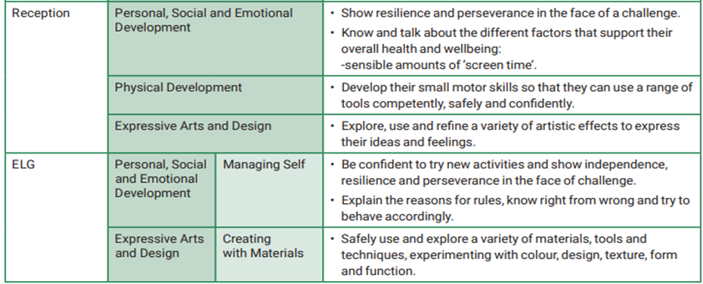

Marwood School Computing Provision

 | Autumn A | Spring A | Summer A | Autumn B | Spring B | Summer B
KS1 | Y1 – Computer Skills  Y2 – Using the internet | Y1 – Online Safety  Y2 – Online Safety | Y1 – Programming Toys  Y2 – Programming Turtle Logo/Scratch Jr | Y1 - Using & Applying  Y2- Using & Applying | Y1 – Word Processing  Y2 – Presentation Skills | Y1 - Painting  Y2 – Computer Art
LKS2 | Drawing and Desktop publishing  Internet research and communication | Online safety Presentation skills  Turtle logo and Scratch | Word Processing Using and applying skills  MultimediaiMovie – Creating a news report | Word Processing  Scratch: Questions and Quizzes | Programming Turtle Logo  Online safety | Using and applying skills  Animation: I can animate on ipads to create moving figures.
UKS2 | Modelling 3D sketch up  Research & present info  Spreadsheets – Enterprise accounts | PROGRAMMING:  Microbit  Fake news | USING AND APPLYING SKILLS | RADIO STATIONS | FILM MAKING | KODU
Whole School | Online Safety Assemblies  Links to PSHE curriculum: Keeping Myself Safe (CORAM SCARF)

